1. Analysis of all the visualization

Worksheet 1

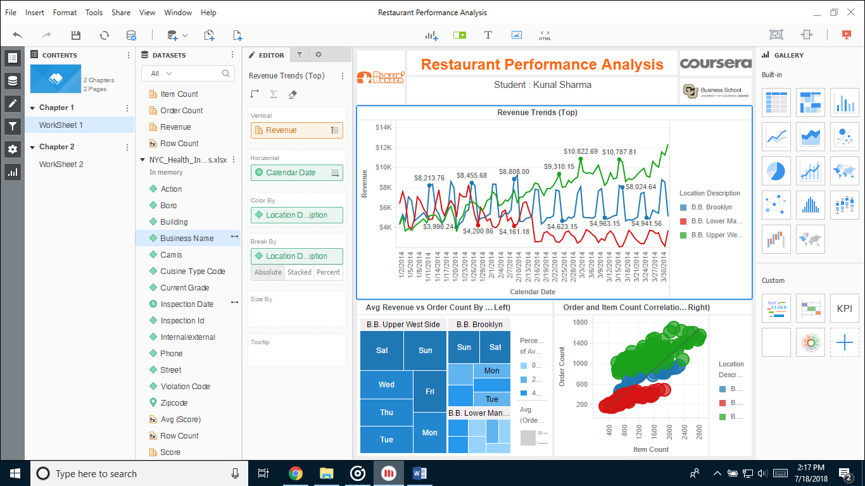

Revenue Trends: Line Chart  
The variation in revenue for three location is shown here, apart from individual location analysis, we can also compare how one location performed against the other two.

Avg (Revenue) vs Order Count by day of Week: Heat Map  
Here we can observe the sales at particular days of the week, in a particular location.

Order and Item Count Correlation: Bubble Chart  
This graph shows correlation between Order and item count. We can see the, based on the trend line, location based order and related item count. Above the trend line means a high correlation, and below means a low correlation.

Analysis:

BB Upper west side restaurant has better performance than the others.  
BB lower Manhattan, is the lowest performer than the other.  
Sat-Sun are the best performing days of the week.  
All three locations had a similar opening, but over time showed variation in revenue generation.

Worksheet 2

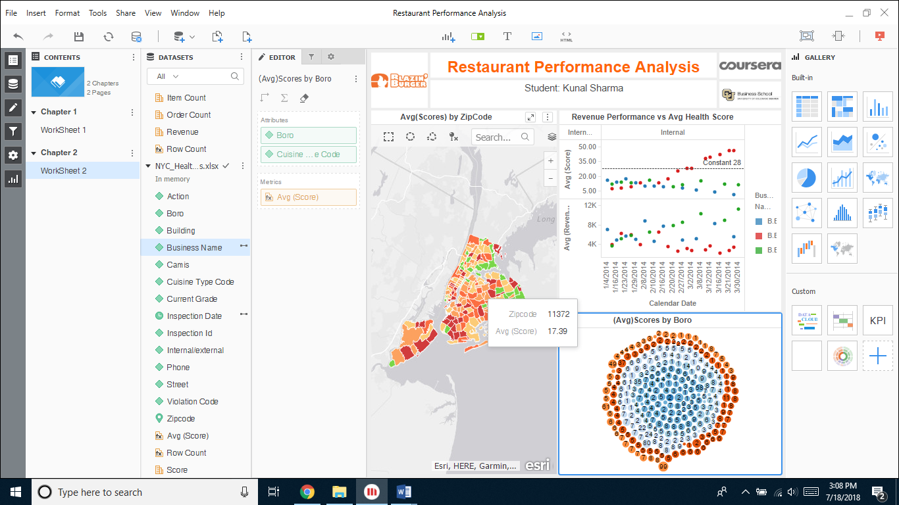

Avg(Scores) By ZipCode: Map  
We can see average score for particular locations and related information in corresponding visualization.

Revenue Performance vs Avg (Health Score): Bubble Chart  
Plotting points for each metric helps in finding difference in performance on each day of the week.

Avg(Score) by Boro: D3 bubble chart  
Showing relation between Boro and Avg(Scores)

Analysis:

We can notice some poor performing area (colored green) in the map.  
BB Lower Manhattan may have the lowest revenue, but has a good score.

1. What else could’ve been done?  
   We could’ve plotted a pie-chart for direct comparison in share of total revenue for the restaurant.  
   We could’ve used grid view for inspection checks on a particular outlet, to keep a track of timely inspection.